***Environmental monitoring Arduino Uno with DHT 11 Sensor using Node-Red***

**Aim:**

The aim of the experiment is to use an Arduino Uno microcontroller and a DHT11 sensor to monitor and gather environmental data, such as temperature and humidity. The collected data will be processed and visualized using Node-RED, an open-source flow-based programming tool, to create a real-time monitoring system. This experiment aims to demonstrate the capabilities of the Arduino Uno and Node-RED in environmental monitoring applications and provide a foundation for further exploration and development in the field of Internet of Things (IoT) and sensor-based environmental monitoring.

**Tool Used:**

Arduino Uno, Node Red, DHT 11 Sensor

**Algorithm:**

* Set up the hardware: Connect the DHT11 sensor to the Arduino Uno board and make sure the Arduino Uno is properly connected to your computer.
* Install the required software: Install the Arduino IDE on your computer and install Node-RED on your computer.
* Set up the Arduino Uno: a. Open the Arduino IDE and create a new sketch. b. Include the DHT library for the DHT11 sensor. c. Initialize the DHT sensor and define the data pin. d. Set up the serial communication to send sensor data to Node-RED.
* Connect the Arduino Uno to your computer via USB.
* Select the appropriate board and port in the Arduino IDE.
* Set up Node-RED: a. Launch Node-RED from your computer. b. Create a new flow in Node-RED.
* Configure the input node in Node-RED: a. Add an MQTT or serial input node in Node-RED. b. Configure the node to receive data from the Arduino Uno.
* Configure the output node in Node-RED: a. Add a visualization or logging node in Node-RED. b. Configure the node to display or log the received data.
* Deploy the Node-RED flow: a. Save the flow in Node-RED. b. Deploy the flow to make it active.
* Monitor the environmental data: a. Ensure that the Arduino Uno is powered on and connected. b. Observe the data displayed or logged in Node-RED. c. Monitor the temperature and humidity readings in real-time.
* Analyse and interpret the data: a. Analyse the collected data for any patterns or trends. b. Use the data to gain insights into the environmental conditions. c. Make conclusions based on the analysed data.

**Snapshot of the Output:**

* **Arduino Uno Window:**

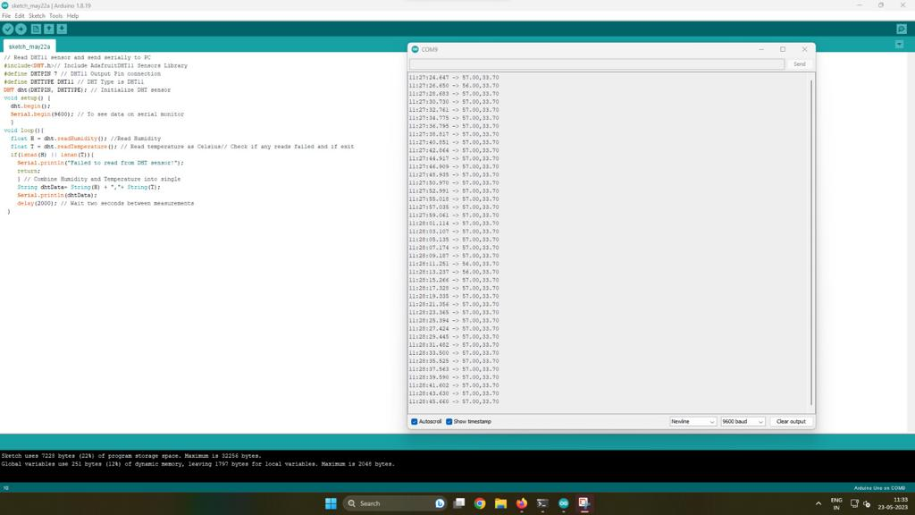

* **Node-red window**

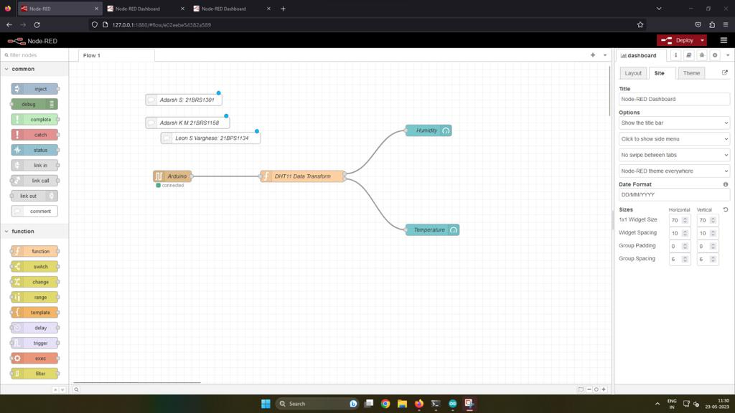

* **DTH-11 Sensor Graph:**

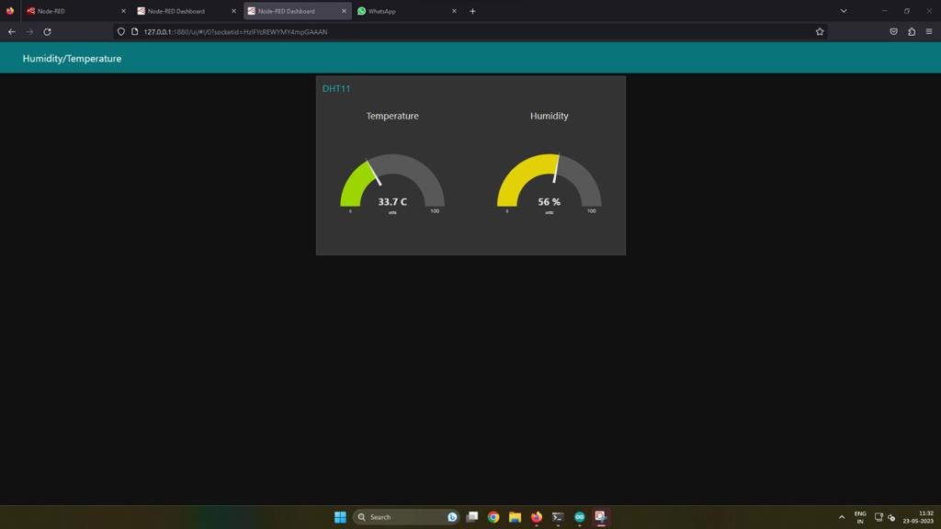

**Result:**

The experiment successfully monitored environmental conditions using an Arduino Uno and a DHT11 sensor. Real-time temperature and humidity data were collected and transmitted to Node-RED for visualization. The data was displayed in charts or graphs, enabling easy interpretation. Additionally, the experiment demonstrated the ability to log and store the data for future analysis. The setup allowed for potential real-time alerts based on predefined thresholds.